Angling Trust Self-Declaration and Disclosure Form
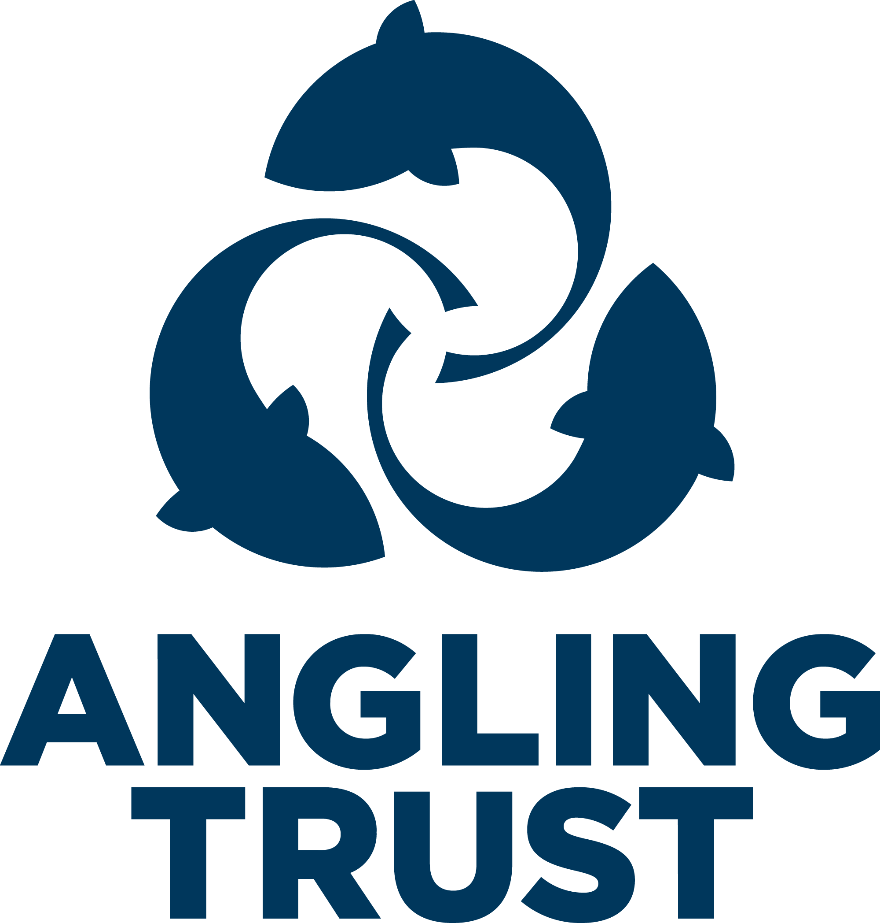

Private and Confidential

For roles involving contact with children (under 18 years) and adults at risk.

All information will be treated as confidential and managed in accordance with relevant data protection legislation and guidance. You have a right of access to information held on you under the Data Protection Act 1998 and Data Protection Regulations 2018

Part One

For completion by the organisation:
Name:
Address and Postcode:
Telephone/Mobile No:
Date of Birth:

Gender: |  | Male / Female
Identification (tick box below):
 | I confirm that I have seen identification documents relating to this person, and I confirm to the best of my ability that these are accurate.
Either
UK Passport Number and Issuing Office
UK Driving Licence Number (with picture)
Plus
National Insurance Card or current Work Permit Number
Signature of authorised Employing Officer:
Print name:

Date:

Part Two

NOTE:
If the role you are in or have applied for involves contact in a regulated activity, more than three times a month, or responsibility for children adults at risk you will also be required to provide a valid DBS (Disclosure and Barring Service) certificate which will provide details of criminal convictions; this may also include a Barring List check depending on the nature of the role (see Angling Trust guidance about eligibility for DBS checks).

For completion by the individual (named in Part one):

Have you ever been known to any Children’s Services department or Police as being a risk or potential risk to children? |  |  | YES / NO  (if Yes, provide information below):
Have you been the subject of any disciplinary investigation and/or sanction by any organisation due to concerns about your behaviour towards children? |  |  | YES / NO  (if Yes, provide information below):
Confirmation of Declaration (tick box below)

 | I agree that the information provided here may be processed in connection with recruitment purposes and I understand that an offer of employment may be withdrawn, or disciplinary action may be taken if information is not disclosed by me and subsequently come to the organisation’s attention.
 | In accordance with the organisation’s procedures if required I agree to provide a valid DBS certificate and consent to the organisation clarifying any information provided on the disclosure with the agencies providing it.
 | I agree to inform the organisation within 24 hours if I am subsequently investigated by any agency or organisation in relation to concerns about my behaviour towards children or young people.
 | I understand that the information contained on this form, the results of the DBS check and information supplied by third parties may be supplied by the organisation to other persons or organisations in circumstances where this is considered necessary to safeguard children.
Signature:

Print name:

Date:

